New Mexico Office of African American Affairs
2020 Year End Report
oaaa.state.nm.us | 9/1/20 | Admin.oaaa@state.nm.us

Table of Contents
Mission
Study, Identify, and provide change through means of support, advocacy, and resources relevant to the African American community.

Vision
To be a “GO TO” authority in New Mexico on matters relating to methods that improve African Americans’ quality of life. We will ensure access to resources by providing valuable resources to constituents, legislators, educators, health care professionals and the Governor.

Brief Overview 2
Town Halls 4
OAAA Programs & Initiatives 8
Census 18
Covid-19 Response 19
Supported Programs 21
Community Support, Partnership and Collaboration 25
Office of African American Affairs staff 27
Executive Advisory Committee 28

Brief Overview

The 44th New Mexico State Legislature enacted the New Mexico Office of African American Affairs (OAAA) in 1999 under House Bill 909 and an executive advisory committee was established by Executive Order under the administration of Governor Gary Johnson. Although the official operation of OAAA started with State Legislation, the hearts of OAAA lies with the many New Mexico residents statewide who felt that there was a need to address issues specific to the African American community.

The impetus for the movement that leads to the creation of OAAA was designed by community leaders who focused on the need to improve and promote the economic development, education, health, and political well-being of the African American community throughout New Mexico. Through efforts that include advocacy, information sharing, cultural awareness, community networking, and influencing legislation, this group of dedicated citizens went to establish a venue that would allow for the support of African Americans throughout New Mexico.

The population of African Americans in New Mexico is approximately 64,914 as of 2018 (DOH). The 3 Counties with the largest population of Black people are Bernalillo (28,201), Dona Ana (6,010), and Sandoval (4,688). There are 10 projected New Mexico Counties with 1000 or more African American residents: Sandoval, Santa Fe, Bernalillo, Dona Ana, Otero, Chaves, Curry, Lea, San Juan, Otero, McKinley as shown in Figure 3.1.
https://ibis.health.state.nm.us/query/result/pop/PopCnty/Count.html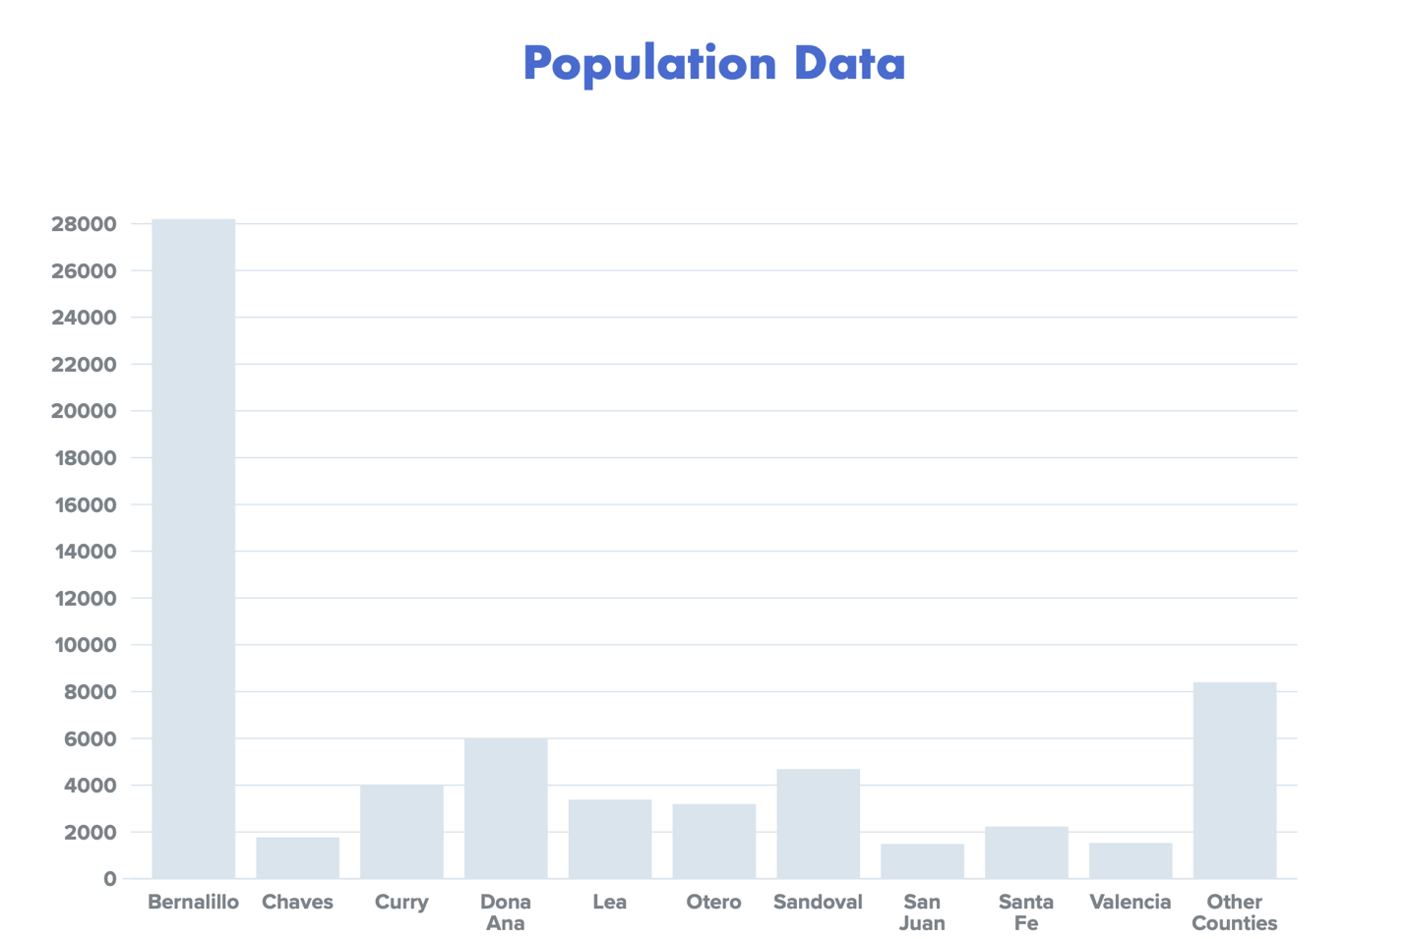
Figure 3.1

In 2018 – 2019, the New Mexico Office of African American Affairs (OAAA) touched 20 New Mexico counties with resources, services and reached over 35,000 individuals in collaborative efforts. The agency has also worked diligently with over 50 collaborating organizations to positively affect the quality of life for African Americans and communities of color.

Town Halls
About
The Office of African American Affairs conducted Town Halls throughout New Mexico to gain knowledge and information on the issues and challenges present in African American communities.

The town hall attendees had the opportunity to come together and express ideas, voice opinions and ask questions pertaining to the climate of their community and bridge the gap between local/regional, community members, and leaders. Our primary objective was to gather the information that helped address challenges and help improve the quality of life through a holistic approach to intervention.
Scope: To obtain knowledge within Major cities in New Mexico to find and understand issues about the African American Community.

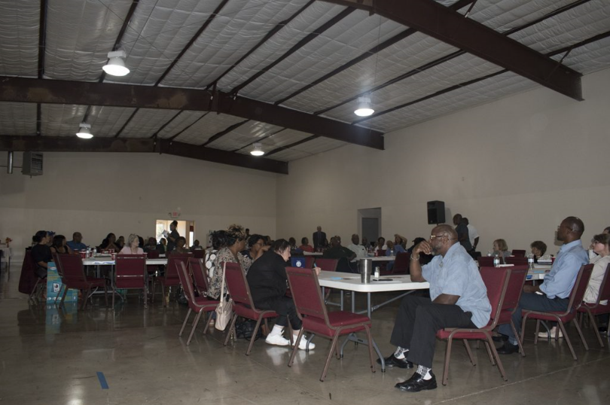

Locations: Farmington, Las Cruces, Hobbs, Clovis, Roswell, and Alamogordo
Town Hall Structure:
- Sign-in
- Introduction – Executive Director
- Explanation of Town Hall format
- Breakout into groups (30 min per topic)
- 5 topics (focus areas)
- Debrief
- Surveys

Duration: 4hrs

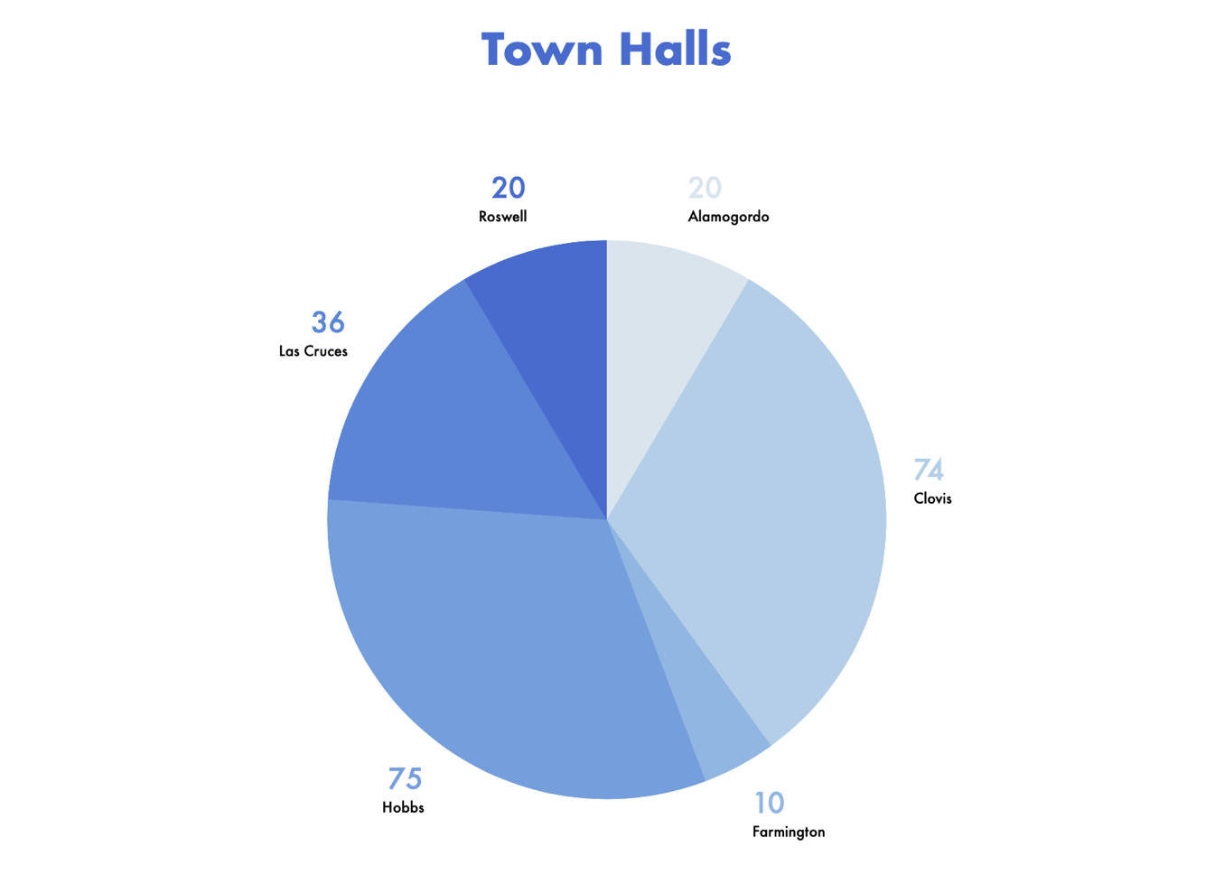
Figure 4.1

Objectives:
- Gain insight into the similar and different challenges that each of these communities’ face, pertaining to the African American Community.
- To create a bridge between officials and community members through dialogue.
- To make ourselves visible to these communities.

Implementation:
- Advocate on policies
- Create, introduce, and enhance programs and initiatives that pertain to observed issues.
- Acquire data to better understand our African American community statewide and what areas to address in each region.

Findings:

Upon consulting with the multiple cities on the plight of the African American communities throughout New Mexico, we observed these commonalities as the main challenges across all the Town Halls.

Key Areas | Issues
Public Safety | - Lack of doctors and healthcare professionals along with services not being provided for kids  - Delayed response time of police departments  - Police are leaving due to low levels of compensation
Community & Economic Development | - Low wages for cost of living  - Training programs/activities for youth  - Loss of youth (leaving city)  - Resources for programs  - Homelessness  - Black businesses  - More opportunities for middle class/minorities  - Lack of public transportation
Education | - No programs for youth (big brothers’ big sisters’/boys and girls club, after school programs)  - Free programs  - Trade schools  - Lack of qualified teachers/Bring teachers in from other areas
Health | - Drug issues  - Mental health awareness/providers  - Lack of quality doctors

The town halls’ findings provided us direction on intervention strategies for the office to use to mobilize the African American community in New Mexico. The basis behind these interventional strategies is supported by aiding the community in understanding legislative processes and providing resources to help them develop communities.

Survey Data:

OAAA conducted surveys to observe the visibility of the office in the community. Through survey analysis, the office gathered insight on how community perception and suggestions into how the African American community can be served. Below are the questions and common responses we received.

Questions | Answers
Have you heard about the Office of African American Affairs and the work that we do? | All 63 participants have heard of OAAA.
Have you ever attended an event sponsored by the Office? | 7 out of 63 said no.  56 out of 63 said they had been to one or more events sponsored by OAAA.
What changes would you like the Office to make in the future to help individuals, groups, and organizations in the state for the African American/ Black Community? | 60 Responses  In observing the community responses statewide, we found that the Office needed to provide increased visibility efforts, collaborating with other Black organizations, while also promoting Black businesses throughout the state of New Mexico.  We also found an emphasis on expanding the Office data hub and providing additional resources that helped with the African American Community.
What is your perception of the Office of African American Affairs? | 60 responses  Upon observing the office’s perception, here are some of the responses: limited its services to only providing information with lack of visibility of other resources, focused primarily on Albuquerque and struggled to advocate on behalf of Black candidates opting to work in a political capacity.  Furthermore, I was encouraged to enlighten the community on policy and legislative processes, providing more structure in a strategic plan and hosting staple events in several communities across the state.

FY 20 Programs and Initiatives

The Agency aims to empower and mobilize the African American community through by implementing programs and initiatives that offer proven strategies that help improve the quality of health, education, and economic prowess. The sponsorship, partnerships, and relationships that the office fosters through community outreach provide the foundation for providing an improved quality resource for African American communities in New Mexico.
ABOUT
The office strives to collaborate with organizations, school boards, city commissions and councils, state officials, and the Governor’s Administration to inform stakeholders of the persistent need for advocacy and policy engagement by implementing programs and initiatives in the African American Community.
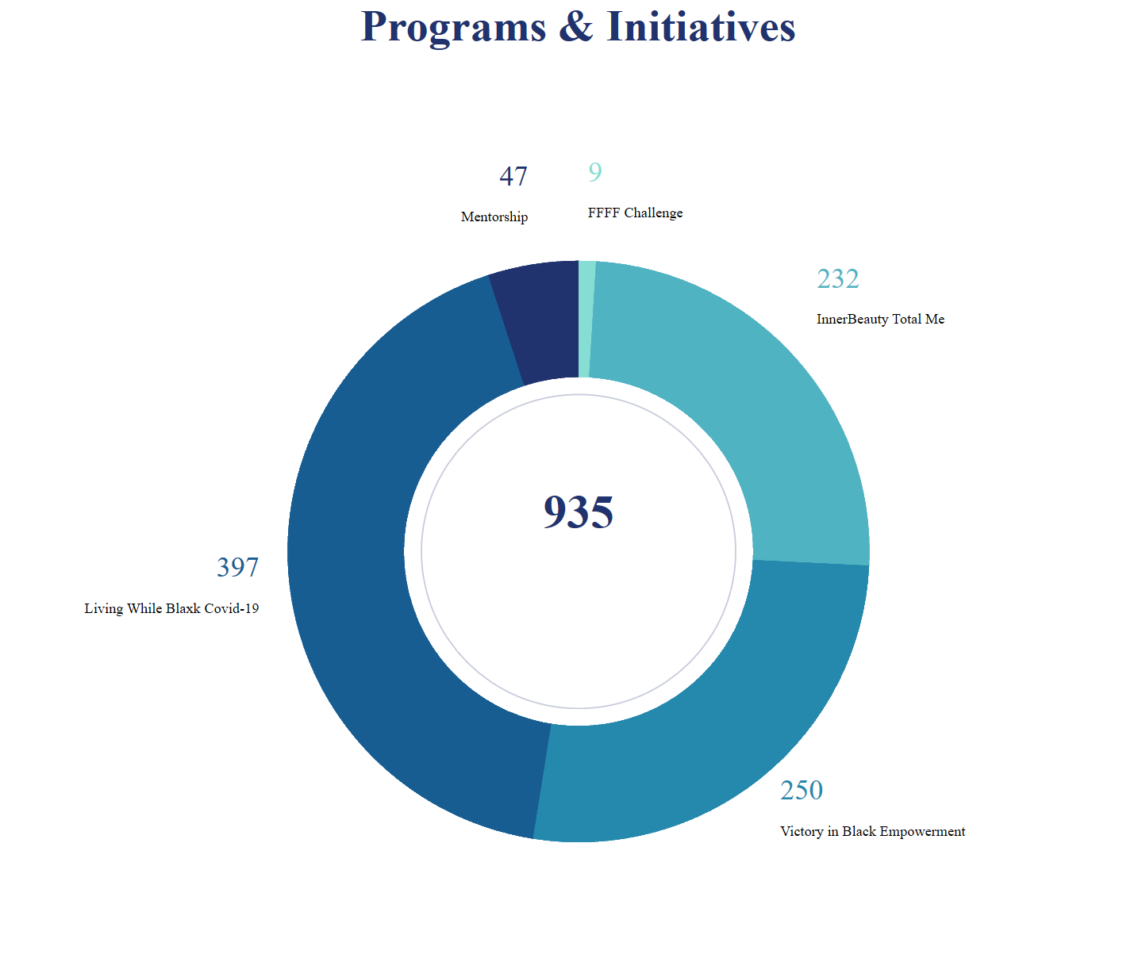

Figure 9.1

Faithful Fathers Family Fitness Challenge
OVERVIEW
Encouraging a healthy lifestyle amongst Black Fathers in Albuquerque by creating a State-Wide Initiative that promoted the health and wellbeing of obese black men in New Mexico.

Purpose:
The FFFF Challenge is to help fathers in the community develop healthier routines regarding nutrition and physical fitness and gain extensive knowledge on those 2 components to aid in the betterment and longevity of their lives.
Figure 10.1
Goals & Objectives: Reduce the negative impact of obesity on the quality of life, reduce medical expenditures and inform the burden of disease and its effects on family and friends.
Measurables: Weigh-ins, BMIU Measurements and Blood Pressure Measurements
Outcome: The average amount of participants per workout session was 4, with the minimum participation was 3, with the maximum participation in a single session was 9. The participants found improvements in their weight and heart rate after the program.

Inner Beauty Total Me Summit
OVERVIEW
The Inner Beauty Total Me, Girl’s on the Rise! is a full day summit that was held on November 18, 2019 and February 27, 2020 at APS Berna Facio Professional Development Center. 3315 Louisiana Blvd NE, Albuquerque, NM 87108.

Purpose: Our mission is to provide young women of color an opportunity to embrace themselves, achieve greater inner strength, and support one another along their journey.

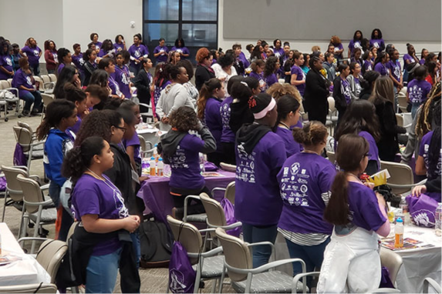
Figure 11.1

Goal: This summit was geared toward middle school female students of color. This summit reached all APS charter and public schools districtwide. Our goal is to reach 300+ middle school-age girls. In addition to the summit, we are developing mentorship programs to continue to support our youth as they transition to the high school level.
Measurables: Participation of middle school young ladies
Outcomes: The Inner Beauty Summit reached the highest single summit count since its inauguration in 2016.

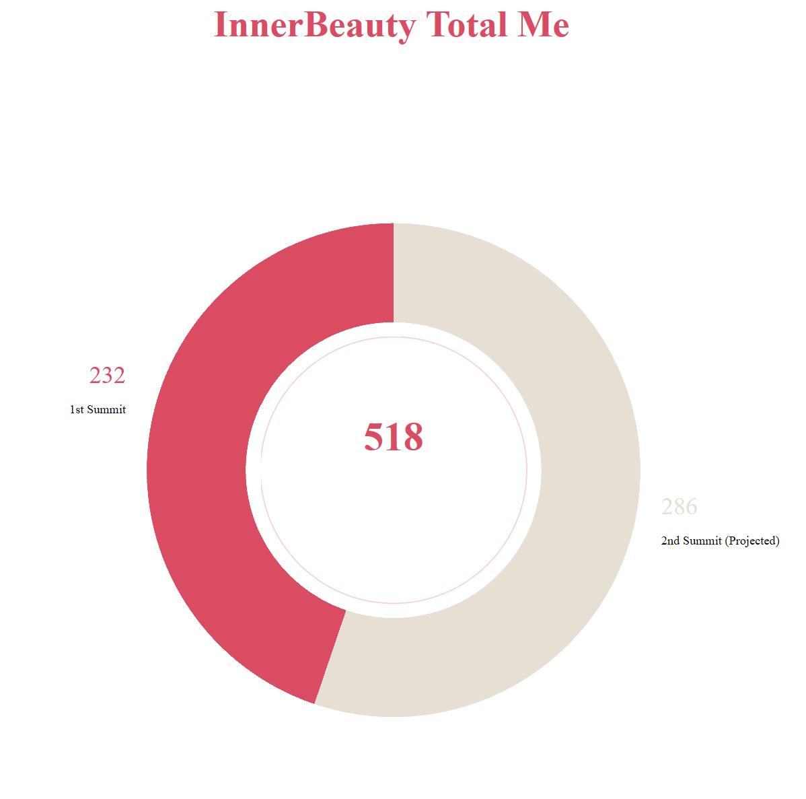
Figure 12.1

Prior to COVID-19, Inner Beauty expected to have its highest turnout reaching approximately 500 female students. Unfortunately, we were only able to have the 1st summit, which had a turnout of 232 female students.

Victory in Black Empowerment Educational Summit
OVERVIEW
V.I.B.E is a one full day summit that was held on January 27, 2020 and February 24, 2020 at Berna Facio, 3315 Louisiana Blvd NE, Albuquerque NM, 87110. This summit is geared toward middle school male students of color.

The Summit was a result of the high demand for a Black male summit after the continuous success of the Innerbeauty Total Me Education Summit.

Purpose: Our mission is to provide young boys of color an opportunity to embrace themselves, achieve greater inner strength, and support one another along their journey.

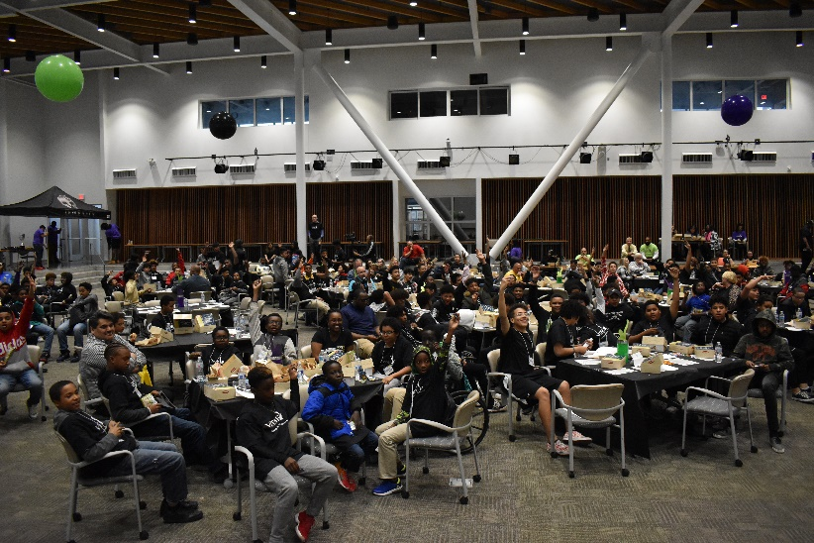
Figure 13.1

Goal: Our goal is to reach 300+ middle school-age boys. In addition to the summit, we are developing mentorship programs to continue to support our youth as they transition to the high school level.
Measurables: The amount of young boys that attended the conference.
Outcomes: The summit was a major success, almost bringing 300 Black male students in its inaugural year. The summit showed to be very powerful in bringing together these young males and Black male professionals.
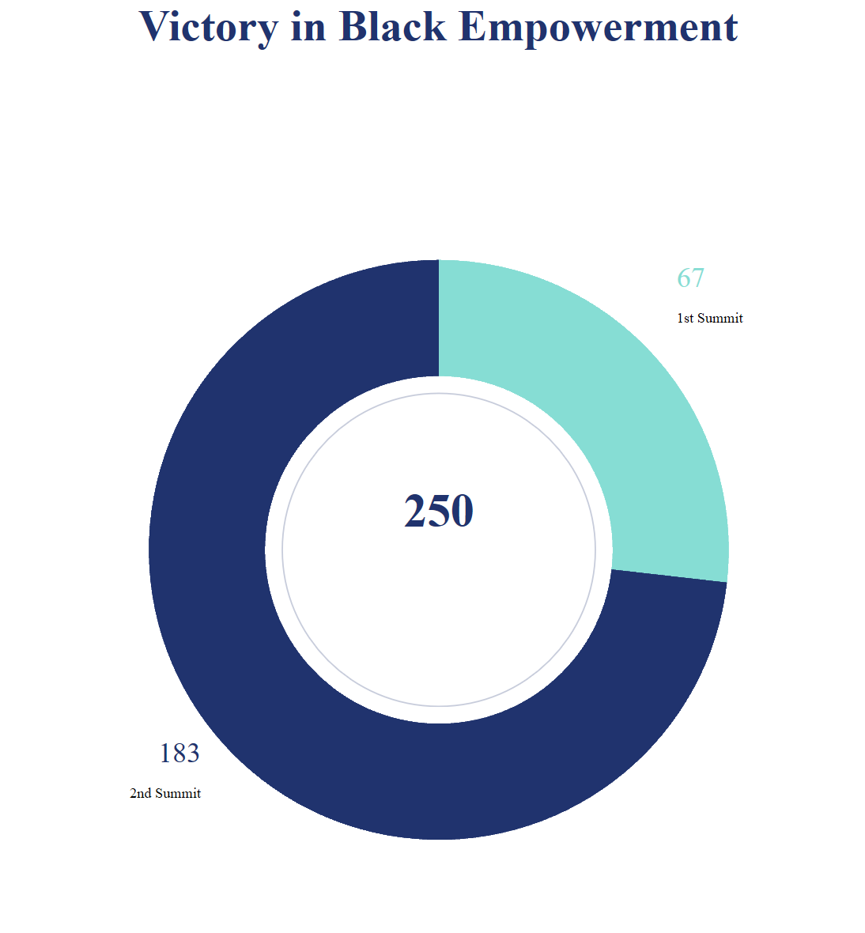
Figure 14.1

The V.I.B.E. Educational summit aided in unifying Black male youth in New Mexico, providing the young individuals an opportunity to see their adult Black male counterparts. With reaching a glowing participation of 250 young gentlemen, OAAA strives to empower the Black youth of New Mexico.

Office of African American Affairs Mentorship Program
Overview
The mentorship program was a follow-up to the “Inner Beauty Total Me” summit, providing intervention to at-risk Black middle school students in two of the Albuquerque Public Schools.

Purpose: The mentorship program acted as a bridge between the students, and Black professionals in the community.

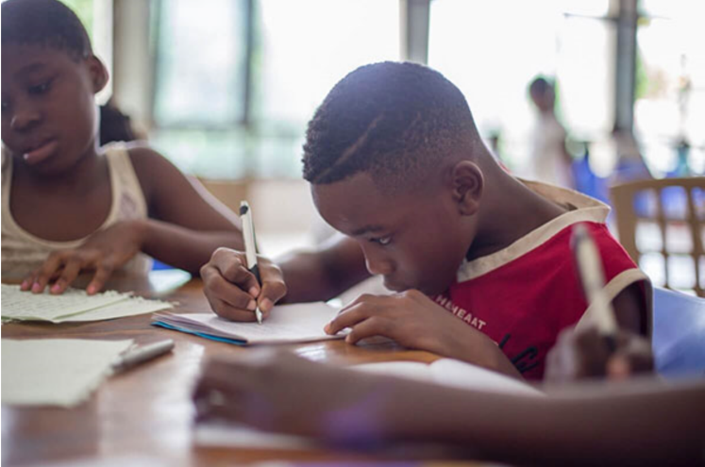
Figure 15.1

Goal: By connecting Black professionals and students, we enhanced the students’ personal, social, and educational development.
Measurables: The number of participants in the program.
Outcomes: Over the course of a year, the students’ 1st cohort showed significant improvement in attendance and GPA.
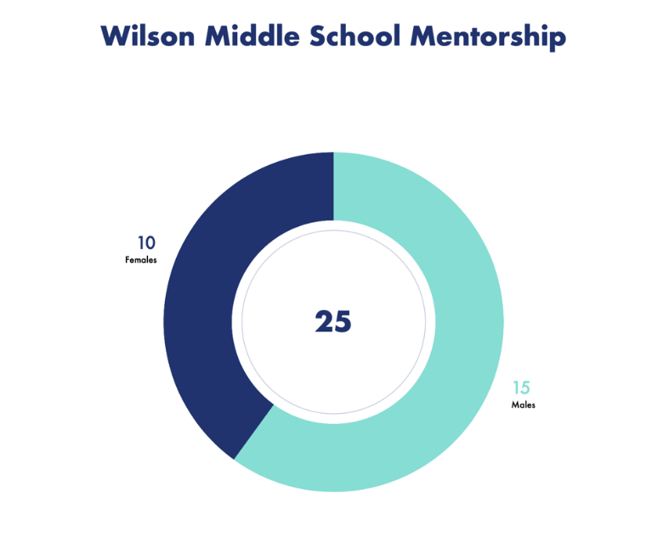
Figure 16.1

Results
Cleveland Middle Schools
Males - 15
Females – 10
Academic
(Males) 20% of students had failing grades (2 or more classes) with C or below.
(Females) 50% of students had failing grades (2 or more classes) with C or below.
Overall

Wilson Middle
Makes - 10
Females - 12
Academic
(Males) 93% of students had passing grades with C or above.
(Females) 90% of students had passing grades with C or above.
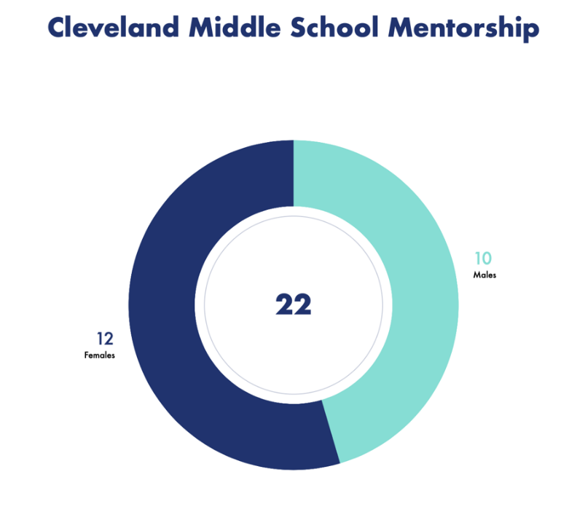
Figure 16.2

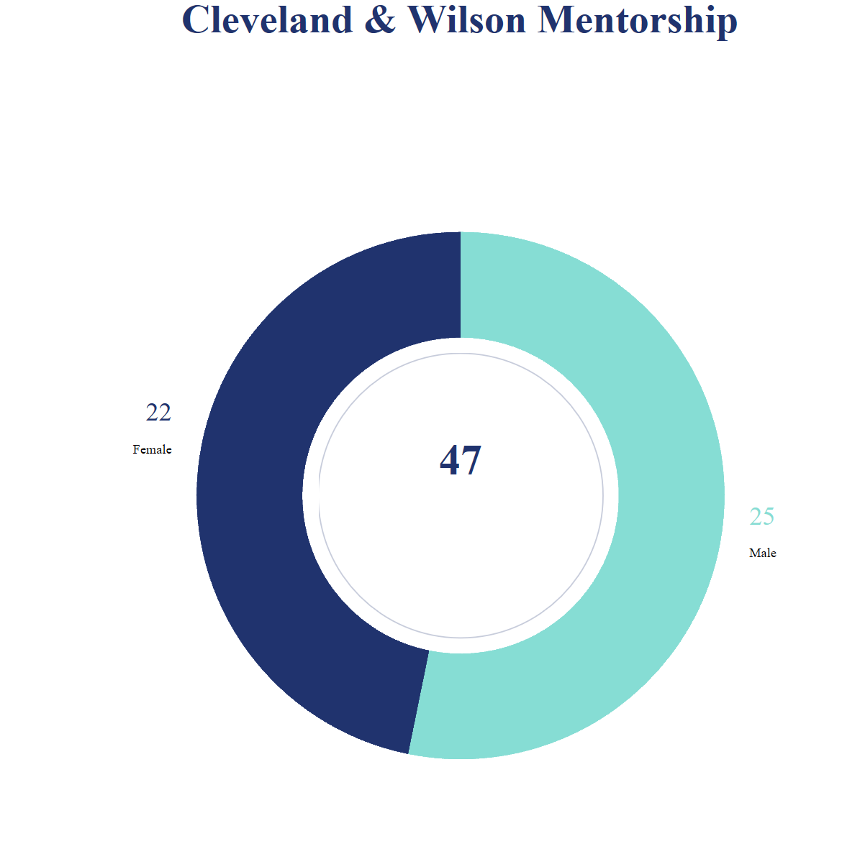
Findings
Absentee
- 85% improvement in male school attendance 3-4 days a week.
- 100% improvement in female school attendance 3-4 days a week.
Discipline
- 75% improvement on male reference to the Principal’s office and suspended. (In and out of school suspensions).
- 80% improvement on female reference to the Principal’s office and suspended. (In and out of school suspensions).
The Overall program showed great improvement in academics and discipline.

Census
Overview
An accurate census is critical because it is used to determine the distribution of federal dollars and political representation for the next ten years.

New Mexico receives over $7 billion each year through federal programs that benefit the entire community: health care, nutrition, highways, education, housing, jobs, and more that allocate funds on a per capita basis.

If NM undercounts residents by only 1%, we would lose $780 Million dollars.
Each New Mexican not counted equates to a loss of $3745 a year.
The U.S. Census asks just ten questions and takes 10 minutes to respond. By April 1, 2020, households should receive an invitation to participate in the 2020 Census.

The U.S. Census Bureau has a legal commitment to keep census responses confidential. The U.S. Census Bureau is required to protect your answers, and all employees take a lifetime oath to protect your information. It’s against the law for them to publicly release your responses in any way that could identify you or your household.
The U.S. Census Bureau will NEVER share information with immigration enforcement agencies like Immigration and Customs Enforcement (ICE), law enforcement agencies like the county sheriff, local police, or the Federal Bureau of Investigation (FBI), or allow this information to be used to determine eligibility for governmental benefits.
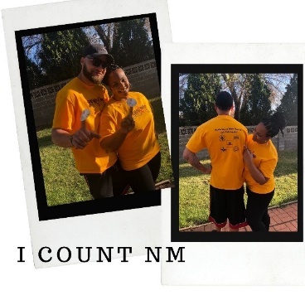
African American households are at risk of being undercounted. The African American population has been historically undercounted in the decennial census, disadvantaging their families, communities, and neighborhoods. In fact:

          - The 2010 Census undercounted the African American population by more than 800,000
          - Approximately 7 percent of young African American children were overlooked by the 2010 Census, roughly twice the rate for young non-Hispanic White children
          - African American men have been historically undercounted in greater numbers than men of other racial or ethnic groups.
          - Today, more than one in three African Americans live in hard-to-count census tracts.

Covid-19 Response

Covid-19 Testing
Due to the Coronavirus's unprecedented appearance, the Agency partnered with the New Mexico Department of Health to conduct Covid-19 testing as an effort to help prevent community spread and minimize infection rates.
Testing Locations:
- Albuquerque, Rio Rancho
- Clovis
- Hobbs
- Las Cruces
- Alamogordo
- Roswell

Total Tested: 1,613
Overview
Coronavirus (Covid-19) is an illness caused by a virus that can spread from person to person. The virus that causes Covid-19 is a new coronavirus that has spread throughout the world. (cdc.gov)
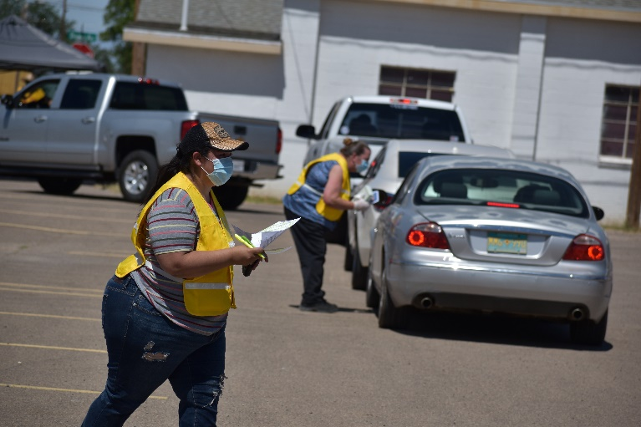

Living While Black Covid-19
Overview
OAAA created a podcast that addressed the issues that surfaced in the Black community due to Covid-19. The podcast provided insight and intervention strategies on how individuals can address these challenges.
Purpose: The podcast discusses issues African Americans in New Mexico are facing, while navigating through the Covid-19.

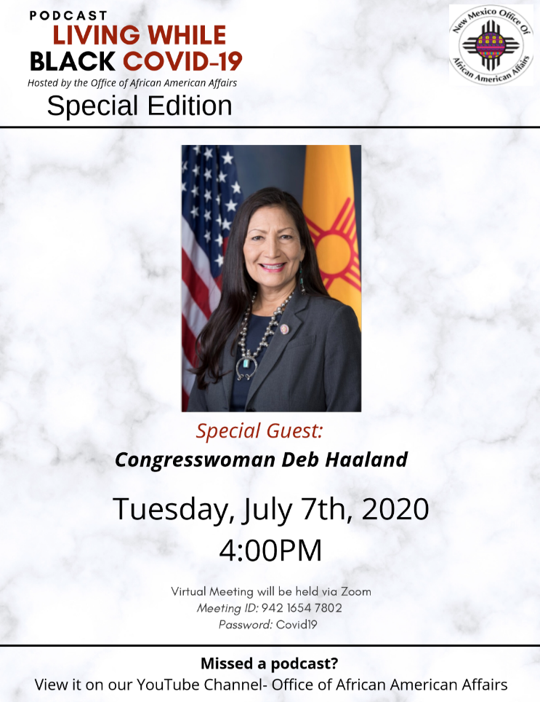
Goal: To provide an innovative way to deliver pertinent information for the Black community in New Mexico
Measurable: The number of views during live and recorded sessions.
Outcomes: The average number of views for the podcast was 70 views with the highest number of views reaching 397 views.

Collaborative Initiatives
The allocation of resources to the African American community is essential to improving their quality of life. We are helping to bridge the gap between the community and other organizations who aspire to help support the African American community, through our collaboration.
Overview
OAAA implements and supports programs and initiatives to aid in the holistic development of the African American community in New Mexico. There is an understanding that we must work together in order to empower and mobilize our community in an effective way.

DOH – Sunshine Muse: Kitchen Creation

Kitchen Creations is a virtual program created and implemented through the adjustment of the Covid-19 Pandemic.

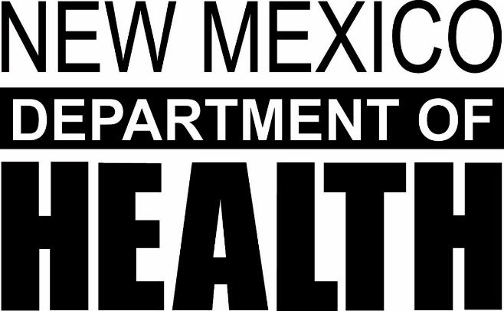

Purpose: Increase knowledge of healthy food choices and meal planning for people with diabetes. Present healthy versions of familiar food and introduce new foods that are economical and easy to prepare.

Goals and Objectives: Provide hands-on opportunities to learn cooking techniques that use new or more healthful ingredients.
Encourage healthier food choices by preparing and tasting healthy foods.
Provide opportunities for participants to share information with families and friends.
Demonstrate the potential of the extension service to provide basic diabetes education in partnership with diabetes health professionals.

Measurables: Participation

Outcomes: Participants gained a better knowledge of what foods to eat. They were educated on food that would raise their blood sugars and foods that wouldn’t. Participants gained knowledge on better ways to shop and prepare foods they love in a healthier way. Participants gained knowledge of reading food labels and learning what the information on a food label means and how it pertains to them.

YMCA – Healthy Heart Ambassadors:

When the program does start, it will be a 4-month program.

Purpose: The office will work in partnership with the YMCA to educate others about the importance of taking their blood pressure and teach them how to do it and record it.
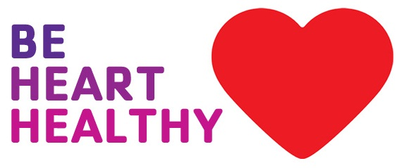
Goal: The goal is to get participants to understand the importance of taking their blood pressure and with that, bring awareness to their readings so we can begin to teach them healthier ways of living that will help control their blood pressure.

Measurables: Participation, Heart Rate

Outcomes: The office coordinators are now trained as Healthy Heart Ambassadors and can now successfully deliver the program.

World Vision International - Food Giveaway

World Vision International is an Evangelical Christian humanitarian aid, development, and advocacy organization. It prefers to present itself as interdenominational and employ staff from non-evangelical Christian denominations. It is active in nearly 90 countries with a total revenue including grants, product and foreign donations of more than $2 billion.
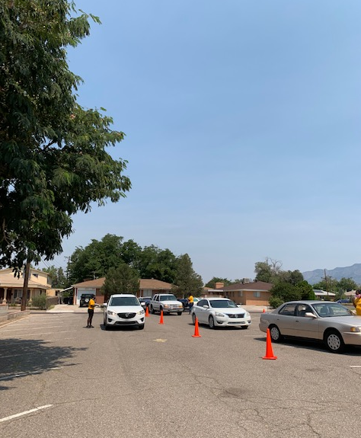

Purpose: World Vision in partnership with USDA, and New Hope Full Gospel Baptist Church and The Office of African American Affairs in a 19-week food giveaway program. This program is designed to assist families during the COVID-19 pandemic.

Goal: The program is open to everyone with a focus on seniors, under and unemployed, and those with children. It has been extended to six local distribution sites: Macedonia Baptist Church, New Beginnings, New Covenant Worship Center, New Hope FGBC, Metro Church COGIC, and Victory Outreach. There is also a distribution site in Otero county.

Measurables: lbs. of food, people served.

Outcome: Each week, 3,000+ people are served and around 37,500 lbs. of food given. The 2020 Census is very important to our communities and our state. Apart from the partnership is to provide census literature that is being distributed each week and having census takers available for those who desire to complete the 2020 census.

Community Partners and Collaborations
Overiew
The community organizations that partnered and collaborated with the Agency have played a pivotal part in implementation of programs and initiatives coming out of the Agency. They have been invaluable to the office and we look to continue to collaborate and partner with these organizations.

NM Women.org
Excellent Schools NM
Alpha Kappa Alpha Sorority, Inc.
Delta Sigma Theta Sorority, Inc.
Zeta Phi Beta Sorority, Inc.
A Peaceful Habitation, Inc.
New Hope Full Gospel Baptist Church
LINKS, Inc.
Dr. Martin Luther King, Jr. Commission
Dress for Success, Inc.
Albuquerque Public Schools (APS)
Lovelace
African American Student Services
B.L.A.C.K. University of New Mexico
African American Student Services
UNM Athletics
Alpha Phi Alpha Fraternity Inc.
Omega Psi Phi Fraternity Inc.
Phi Beta Sigma Fraternity Inc.
University of New Mexico Athletics
A Better U Barbershop Academy
Gladiators

Office of African American Affairs Staff

William Scott Carreathers has been appointed the Executive Director of the State Office of African American Affairs, by the Honorable Governor Michelle Lujan Grisham on January 1st, 2019.

Nicole Bedford is the Deputy Director of the State Office of African American Affairs. She has been with the agency for 8 years

Beverly Jordan is the Lead Outreach Coordinator of the State Office of African American Affairs. She has been with the agency for 5 years.

Devon Williams is a Social and Community Outreach Coordinator of the State Office of African American Affairs. He has been with the agency 9 months.

Chaslyn Wenze is a Social and Community Outreach Coordinator of the State Office of African American Affairs. She has been with the agency 9 months.

Andrea “Tammy” Watson is the Executive Assistant of the State Office of African American Affairs. She has been with the agency for 1 year.

Rebecca Garcia is the Budget Analyst of the State Office of African American Affairs. She has been with the agency for 1 year.

Executive Advisory Committee

​Dr. Jack Taylor – Albuquerque, NM
Joe Cotton – State President, NAACP | Hobbs, NM
Kalonji Mwanza – Albuquerque, NM
Kimberly York – Interim Director of Black Programs, NMSU | Las Cruces, NM
Orlando Leavell – Albuquerque, NM
Van Tate – Reporter, KOAT | Albuquerque, NM
Brandi Stone – Director of African American Student Services, UNM | Albuquerque, NM
Dr. Ndidiamaka Okpareke – Pharmacist | Rio Rancho, NM

